**MIA Task5.2**

Fares Elzeny – E4660

1. **3-bit Encoder with Sampling Time = 0.25 sec**

* **Sampling Points**: 0, 0.25, 0.5, 0.75, 1, 1.25, 1.5, 1.75, 2 sec
* **Quantization Levels**: 8 levels (0 to 7)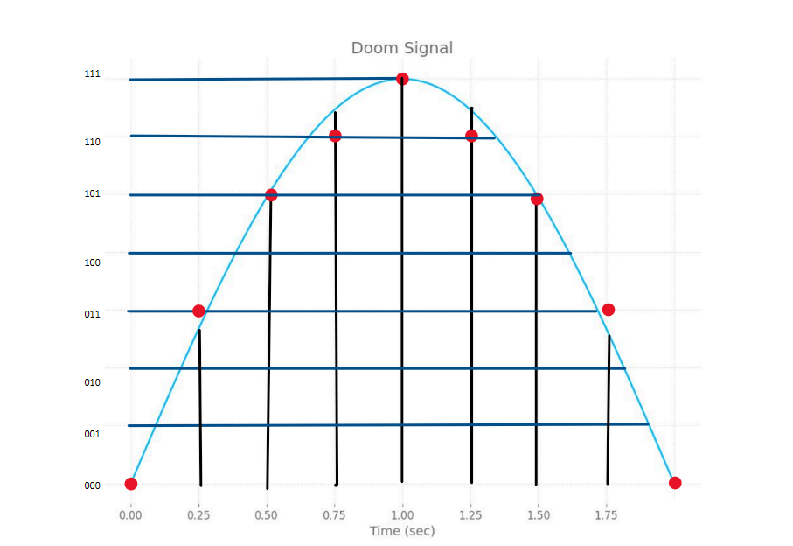

**Bit sequence**: 000 011 101 110 111 110 011 000

1. **3-bit Encoder with Sampling Time = 0.5 sec**

* **Sampling Points**: 0, 0.5, 1, 1.5, 2
* **Quantization Levels**: 8 levels (0 to 7)

**Bit sequence:** 000 101 111 101 000

1. **3-bit Encoder with Sampling Time = 1 sec**

* **Sampling Points**: 0, 1, 2 sec
* **Quantization Levels**: 8 levels (0 to 7)

**Bit sequence:** 000 111 000

1. **2-bit Encoder with Sampling Time = 0.25 sec**

* **Sampling Points**: 0, 0.25, 0.5, 0.75, 1, 1.25, 1.5, 1.75, 2 sec
* **Quantization Levels**: 4 levels (0 to 3)

**Bit sequence:** 00 01 10 11 11 11 10 01 00

**Conclusion:**

* **Higher Sampling Rate:** Captures more details of the signal but requires more data storage.
* **Higher Bit Depth:** Provides better resolution but increases complexity and data size.